Remote Desktop Connection (RDP)
Official URL: https://services.smsu.edu/TDClient/180/Portal/KB/Article/4278/Remote-Desktop-Connection-RDP
Category: Knowledge Base > Information Technology Services > Computer, Device, and Printing Support > Remote Desktop Connection (RDP)
Tags: windows, RDP, remote
_____________________________________________________

Remote Desktop Connection (RDP)
Remote Desktop Connection (RDP) allows faculty and staff to securely access their on‑campus work computers from off campus. Using RDP, you can:
- Use specialized software installed on your campus workstation
- Access internal drives and network resources
- Work with files and folders that may not be available through cloud services
This service is available to all SMSU faculty and staff. Access must be requested through the Technology Resource Center (TRC) before first use.

Instructions on how to use Remote Desktop Connection
- Step 1: Log into your SMSU issued device and connect to the VPN. For help connecting to the VPN, please read the Virtual Private Network (VPN) article.
Step 1: Log into your SMSU issued device and connect to the VPN. For help connecting to the VPN, please read the Virtual Private Network (VPN) article.
- Step 2: Open Remote Desktop on your computer. You can do this by searching "Remote Desktop Connection" in the windows search bar and clicking on it.
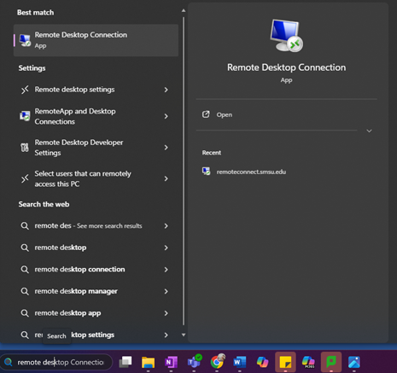
Figure 1: Windows Start search results displaying ‘Remote Desktop Connection’ as the best match.
- Step 3: Type the name of the computer you want to remote into and if prompted type in your username using the format "smsu\starID" (e.g. smsu\ab1234cd) and hit connect
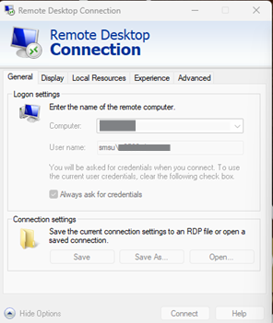
Figure 2: Remote Desktop Connection window showing fields for computer and username, with connection settings and save options.
- Step 4: After hitting connect you will be prompted to type in a password. Please type in the password associated with your StarID.
If you would like to be remembered on the device you are using you may also select "Remember me".
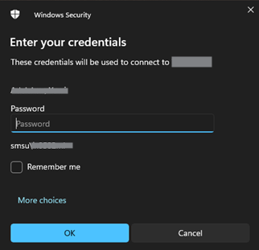
Figure 3: Windows Security prompt asking for credentials, including password field and remember-me option.
- Step 5: After typing in your password you should have access to your desktop and all the materials that are in it.
Step 5: After typing in your password you should have access to your desktop and all the materials that are in it.

Instructions on setting up RDP with multiple displays
NOTE: Please make sure you are closed out of any open RDP sessions.
- Open Remote Desktop Connection and enter the name of the computer you want to remote into
- Click on Show Options
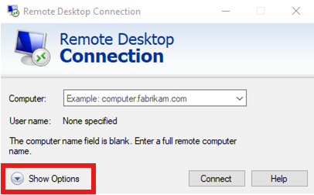
Figure 4: Remote Desktop Connection window with fields for computer and username, and the ‘Show Options’ button highlighted.
- Click on Display
- Check the box in front of use all my monitors for the remote session and make sure you drag the slider all the way to the right.
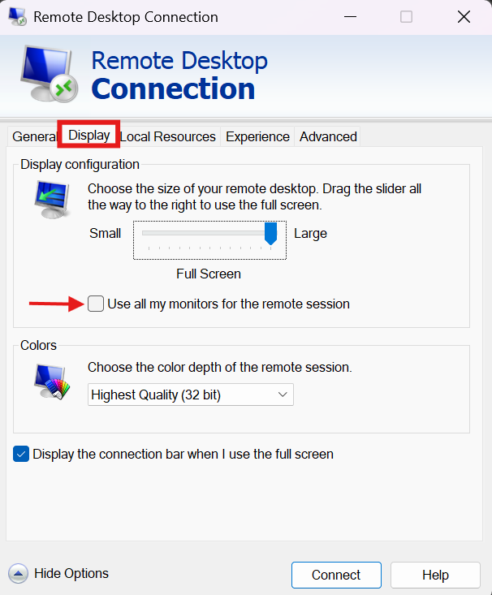
Figure 5: Remote Desktop Connection Display tab showing screen size slider and ‘Use all my monitors for the remote session’ option.
- Click on Connect
Accessibility Review & Update Log:
- [x] Content accuracy and link integrity verified
- [x] High-contrast visual hierarchy implemented (Inter and Calibri)
- [x] Image alt-text captions verified (all screenshots captioned)
- [x] PDF attachments scraped and fully inlined directly inside the document
- [x] Outline headers and standard list sequences optimized for screen readers

